SOCIAL ANALYTICS ASSIGNMENT-1

TEJASAV MADAAN

ROLL NO- R100217082

SAP ID- 500062414

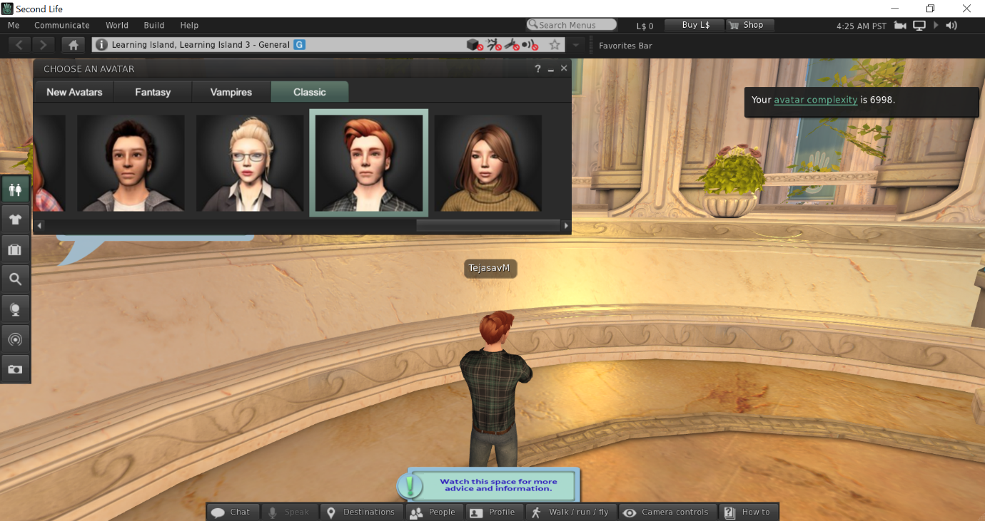

Setup: This is the intro page which makes us familiar with the interface and controls of the application and selecting your type of avatar.

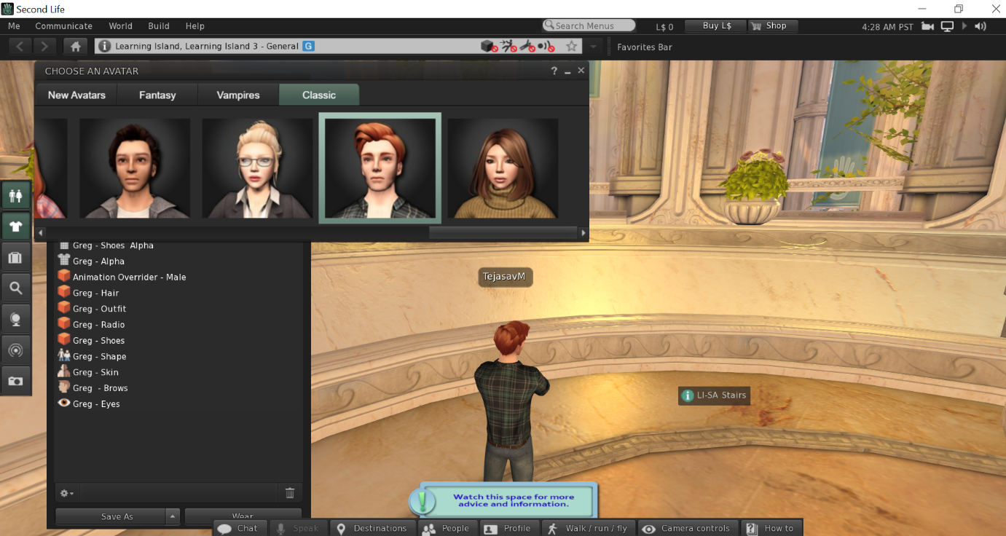

You can select the type of outfits you want to select by clicking on the outfit icon on the left panel of the screen.

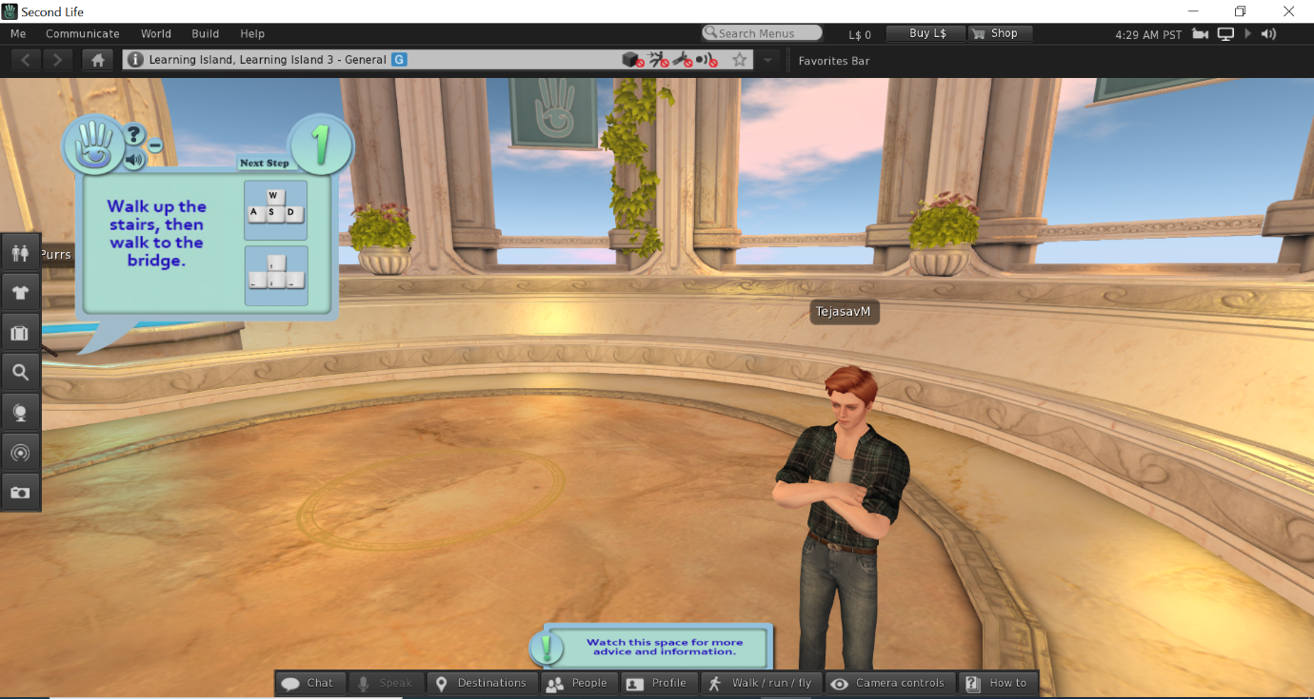

Avatar can be control with the combination of keyboard and mouse. W,A,S,D/arrow keys to move and E to jump, page up or E to fly and page down or C to come down. The mouse is useful in viewing different camera angles

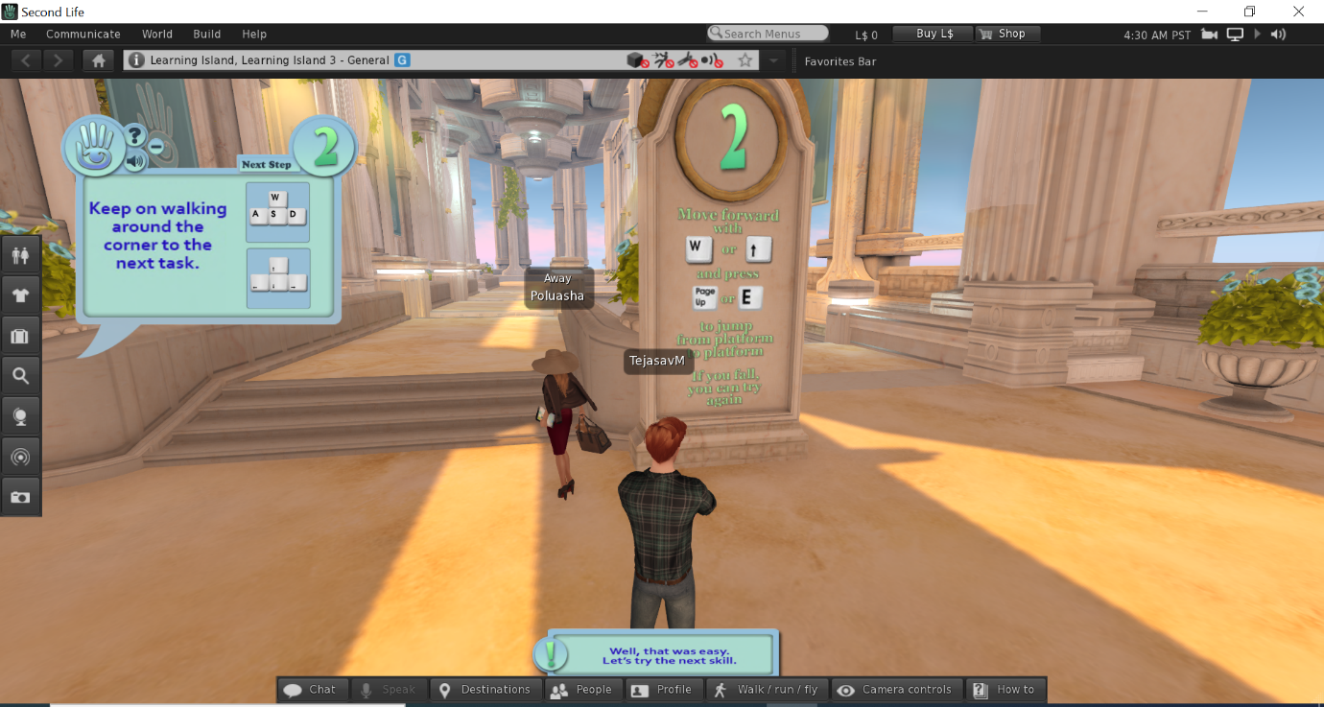

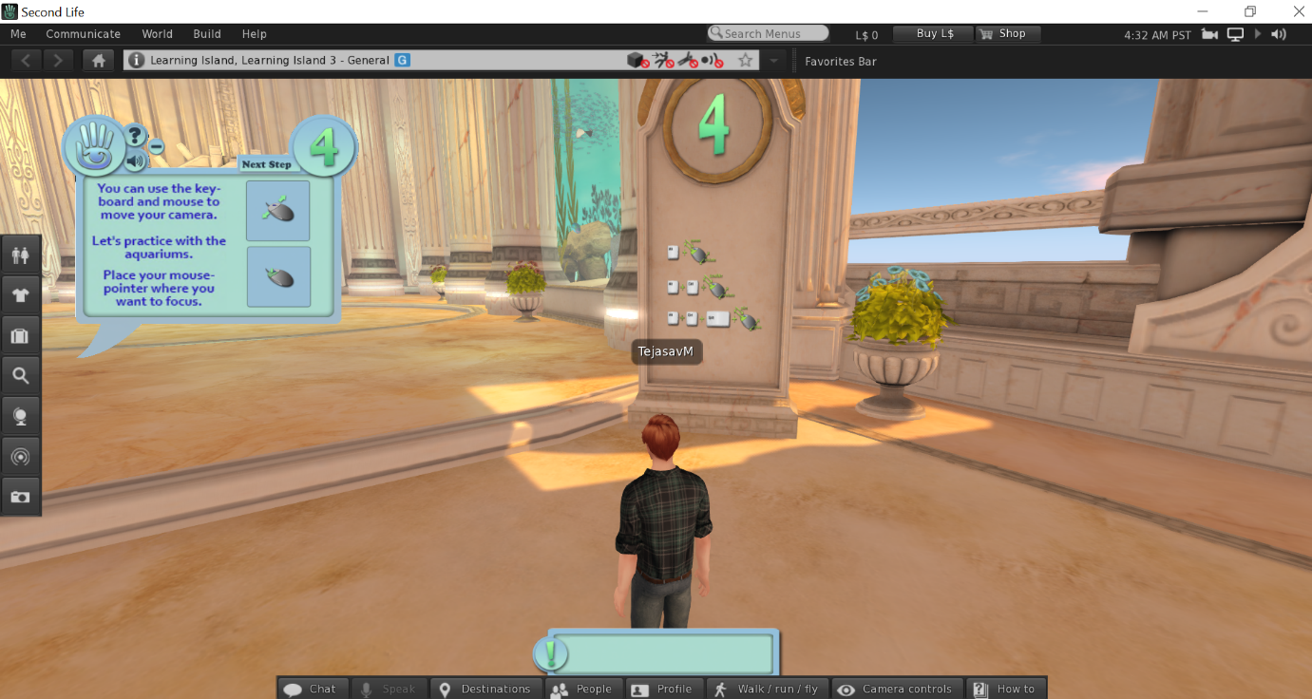

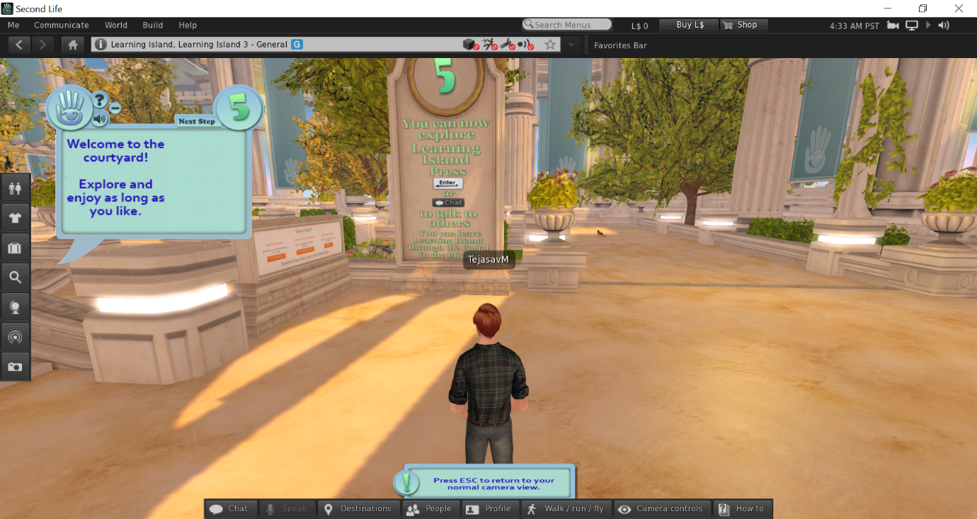

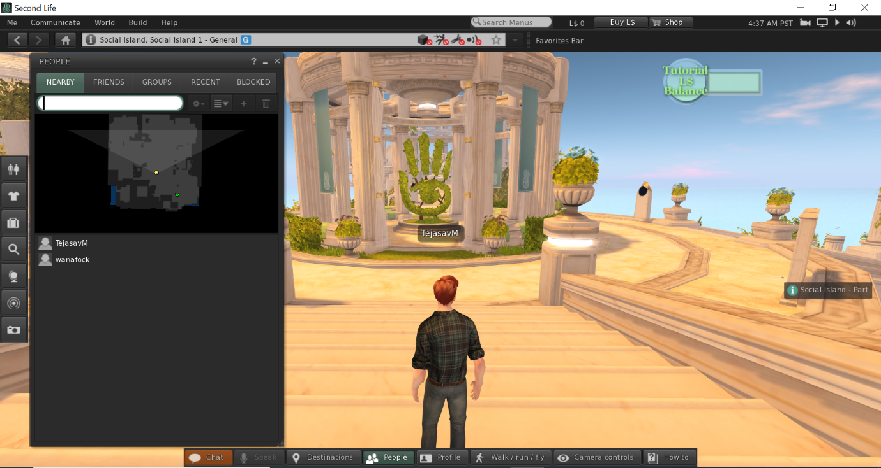

There are several different locations/ maps to choose from and walk around.